**Data Structures and Algorithms**

**Lab Report**

**Lab01**



|  |  |
| --- | --- |
| Group Members Name & Reg #: | **Muhammad Haris Irfan**  **(FA18-BCE-090)** |
|  |  |
| Class | Data Structures and Algorithms CSC211 (**BCE-3B**) |
| Instructor’s Name | Dilshad Sabir |

**In Lab Tasks**

**Task 1:**

**Build and run the program given in Code Listing 1.**

**Solution:**

After running the program in codeblocks, solution is shown below.

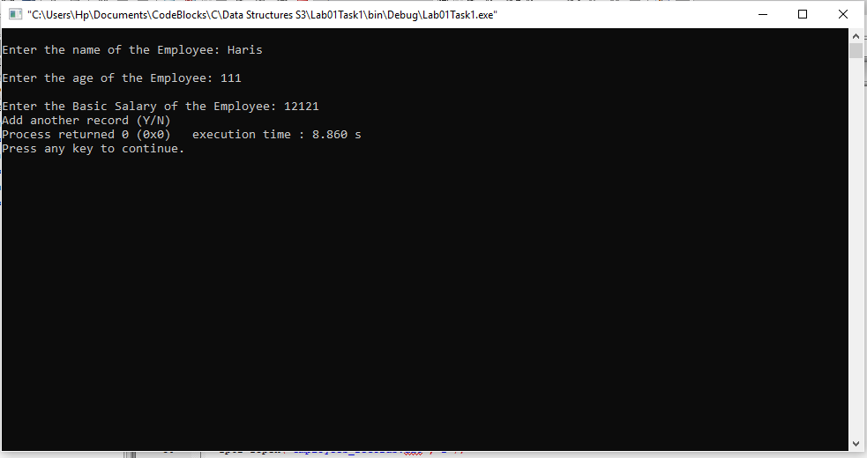

____________________________

**Task:2**

The program in Code Listing 1 writes a single record to the file. Modify it, to use a function ‘**write_records_to_file**’ with following prototype:

int **write_records_to_file** (struct emp * sptr, int num_records, FILE * fptr)

This function should write **’num_records’** number of structures from a dynamically allocated memory pointed to by ‘**sptr’** to a file pointed to by **‘fptr’**. It should return the number of structures successfully written to the file.

Solution:

I am attaching my code below, for this program,

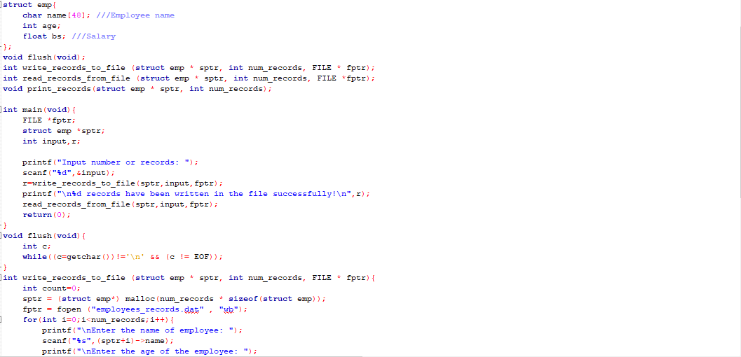



The result for this program is shown below,

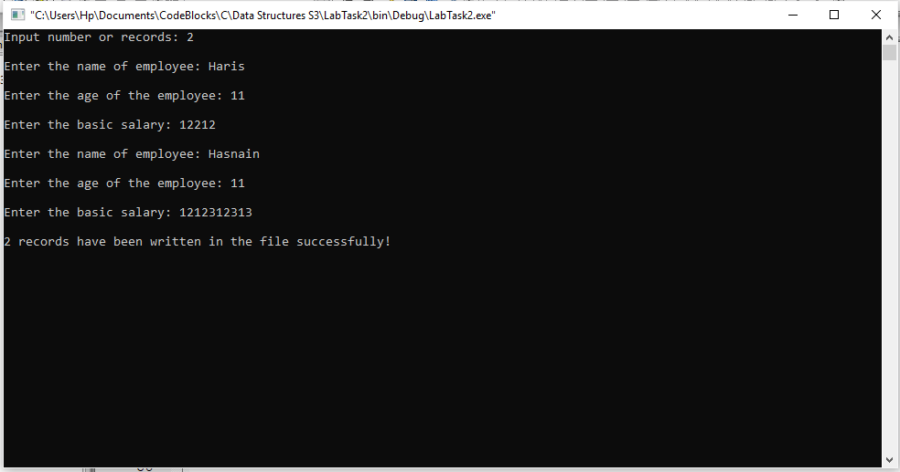

_____________________________

**Task:3**

Write functions ‘read_records_from_file’, and ‘print_records’ with following prototypes:

int **read_records_from_file**(struct emp * sptr, int num_records, FILE * fptr)

void **print_records**(struct emp * sptr, int num_records);

Solution:

I am attaching my code below, for this program,

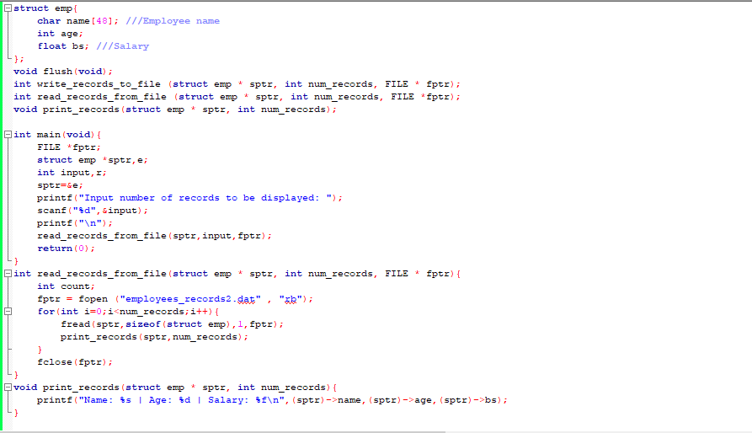

The result for this program is shown below,

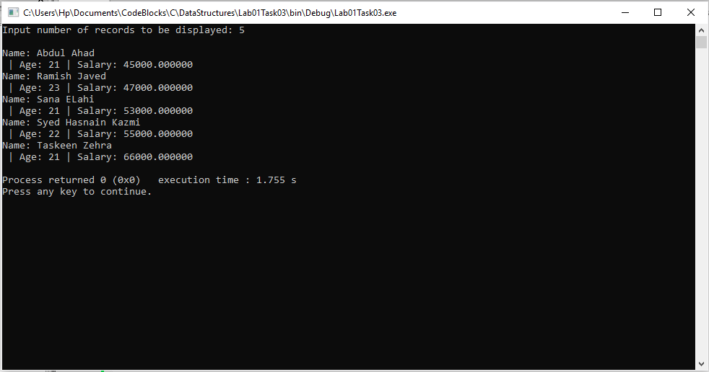

_____________________________

POST LAB

Question:

The structures that you write in a file using ‘fwrite()’ are written in the binary format and cannot be viewed in a text editor properly. Your task is to write the contents of these structures in the text format so that the contents may be viewed in a text editor.

Solution:

When we run our code and input data,

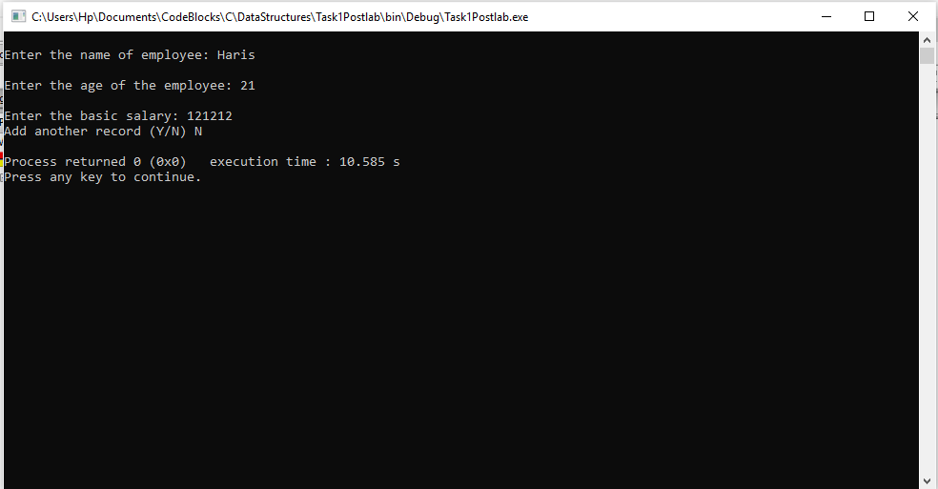

The data is stored in notepad in text format,

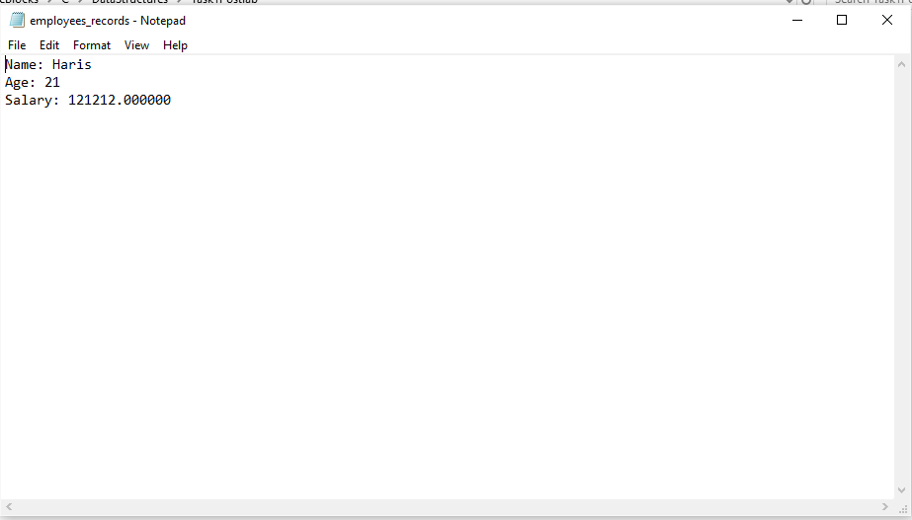

______THE END________